PRESS RELEASE JDN105

AIR OPERATED HOISTS ARE THE SAFE CHOICE
FOR SPRAY BOOTH OPERATIONS

Air hoists from the J D Neuhaus Profi range have been successfully utilized within a paint booth to facilitate the movement of material in and out of the booth. The installation has helped to boost productivity and was carried out by Engineered Lifting Systems (ELS), a major representative in the USA for the J D Neuhaus (JDN) range of high performance air operated lifting equipment.

ELS are particularly proud of this upgrade, carried out for a spray booth operated by one of their customers. The customer is equally pleased with the improved performance and increased output they have achieved, as well as maintaining a high finish level for their product lines.

The handling of components, designated for spray booth coating operations, had previously been undertaken utilizing two manually operated chain hoists located on an overhead rail running the full length of the booth. The hoists provided the necessary lift and full horizontal travel movements required for work pieces being sprayed, with all the manual actions necessary being undertaken by the spray booth personnel. With individual loads of up to 2 metric tons being catered for, it was obvious that fully mechanized load movements would improve working conditions, increase productivity and potentially enhance finish quality.

Continued ……
ELS was both happy and confident to recommend the JDN Profi 2TI air operated hoists to their customer as the logical replacement for their existing pair of manually operated chain hoists. The choice of air operation throughout (for both lifting and load horizontal movement functions) ensured that the new hoists covered NEC ruling requirements to meet or exceed NFPA 33 standards. In fact the JDN products have a European rating EX II 2 GD IIA T4 / II 3 GD II T4 as standard, providing safe operation within hazardous or potentially explosive atmospheres as can exist in spray painting operations. Even higher safety ratings can be accommodated where increased spark protection is specified to achieve the EX II 2 GD IIC T4 safety standard.

The JDN hoists operate within an air pressure range of 65 or 85 psi, and when being used at the higher pressure rating a lift capacity of 2 metric tons per hoist is available, combined with a full load lift speed of 8.9 feet/min being achieved. All lift and load traverse movements are undertaken using pendant controllers (single handed operation), with a pendant drop length provided to ensure that it can fully clear any freshly sprayed objects as well as providing a good working clearance for the spray gun operator. The hoists are suspended from trolleys running on the overhead standard beam, so providing the horizontal load movement. Each hoist is fitted with an airline filter regulator unit and a steel chain retention box, together with a muffler/oil collector to prevent spent oil mist dripping onto newly painted products.

The JDN Profi TI range of hoists are very robust and include units with individual lift/load capacities from 550lbs up to an impressive 100 metric tons. These hoists may be used for oblique pulling under special safety provisions. In addition, hoists can be fitted with optional trolleys which run in an overhead support beam to provide horizontal load movements. Trolleys available include manual, reel chain or motor operated versions, depending upon the degree of mechanization required.

Continued ……
The lift/lower and travel movements where incorporated are controlled with pendant hand controls. Ten feet lift chains and pendant control air supply leads are provided as standard, with other specific lengths available to suit user requirements. Optional operating systems are available including rope control, together with sensitive, single speed and multi function controllers, as well as both remote control and electropneumatic interface units.

These JDN products are suitable for safe operation within hazardous areas and provide lube-free operation with no downtime. They are also 100% duty rated, with unlimited duty cycle capability and featuring fail-safe starting. They are also insensitive to dust and humidity as well as environmental operating temperatures ranging from -20°C to +70°C.

Further information is available on request to:
J D Neuhaus L.P., 9 Loveton Circle, MD 21152 Sparks, USA
Contact: Peggy Weber e-mail: p.weber@jdneuhaus.com
Office Phone: 1-888- NEUHAUS www.jdngroup.com

Worldwide contact details for J D Neuhaus can be seen at the end of this press release.

facebook.com/jdneuhaus www.jdngroup.com/plus

(approximately 720 words
including photographic annotations)

Continued ……
General Information

Supplier: J D Neuhaus L.P.

Press Release No: JDN105

Press or publishing inquiries to: Steve Lloyd
Enterprise Marketing Services Ltd
The Coach House, 1 Dunstall Road, Barton under Needwood,
Burton on Trent, Staffordshire, DE13 8AX, UK
Tel: +44 (0) 1283 713185
Fax: +44 (0) 1283 716172
e-mail: info@enterprise-marketing.co.uk

Reader response inquiries to: Ms Peggy Weber of J D Neuhaus L.P.

Downloads: The press release text (MS Word and PDF format) and image are
available for download at:

www.enterprise-marketing.co.uk/jdn/jdn105.html

Our Reference: JDN105/16/02/V3

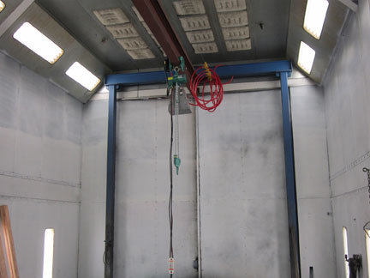
One of two air operated JDN Profi 2 TI hoists newly installed in a paint spraybooth.
Download high resolution 300dpi image
Download low resolution 72dpi image

Continued ……
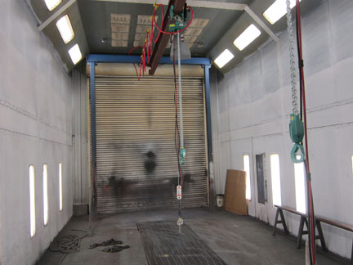
Twin JDN hoists after installation and load testing, with individual load hooks and air operated pendant controllers.
Download high resolution 300dpi image
Download low resolution 72dpi image

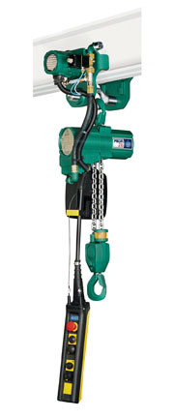
Profi 2 TI hoist from J D Neuhaus, successfully installed in a spray booth by JDN representative Engineered Lifting Systems.
Download high resolution 300dpi image
Download low resolution 72dpi image
Continued ……
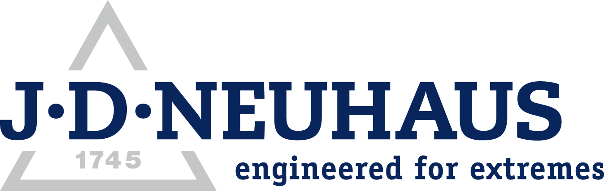
Company information

J D Neuhaus are a privately-owned company, founded in 1745, and for over 270 years they have been using their expertise and experience to manufacture the highest quality hoists and cranes.

Their products offer solutions to almost every material handling problem irrespective of the driving medium: from air and hydraulic hoists up to complete crane installations with explosion proofness.

JDN products are used in a wide variety of industries including:
Airplane Yards; Atomic/Coal Power Stations; Big Bag Handling; Cement Industry; Chemical Industry;
Crane Manufacturers; Dairies; Food Industry; Foundries; Galvanization; Glass/Ceramics; Large Kitchens;
Leather Plants; Locks; Machine and Plant Construction; Mining; Motor Car Industry; Offshore/Onshore;
Oil Storage; Over/Underground Construction; Paints and Varnish; Painting and Coating Installations;
Paper Industry; Pharmaceutical Industry; Printing Industry; Pyrotechnics Industries; Refineries; Sawmills; Shipbuilding and Shiprepair Yards; Ships; Space Technique; Spray Booths; Steel Works; Surface Technique;
Tank Cleaning Devices; Textile Industry; Tunnel; Tire Manufacturers; Vacuum Technique

Contact J D Neuhaus

J D Neuhaus are represented in more than 90 countries and over 70 branches Worldwide.

Germany
J D Neuhaus GmbH & Co. KG, 58449, Witten-Heven, Germany
Tel: +49 2302 208-219 Fax: +49 2302 208-286
e-mail: info@jdngroup.com www.jdngroup.com

France
J D Neuhaus S.A.R.L., 24, rue du Président Krüger, 69008, Lyon, France
Tel: +33 4 3790-1745 Fax: +33 4 3790-1746
e-mail: info@jdneuhaus.fr www.jdngroup.com

Great Britain
J D Neuhaus Ltd, Unit 6 Kirkton Avenue, Pitmedden Road Industrial Estate, Dyce, Aberdeen, AB21 0BF, UK
Tel: +44 1224 722751 Fax: +44 1224 729895
e-mail: info@jdneuhaus.co.uk www.jdngroup.com

Singapore
J.D. Neuhaus Pte. Ltd, 21 Toh Guan Road East, #09-02 Toh Guan Centre, 608609, Singapore
Tel: +65 62758911 Fax: +65 62758922
e-mail: info@jdn.com.sg www.jdngroup.com

USA
J.D. Neuhaus L.P., 9 Loveton Circle, MD 21152 Sparks, USA
Tel: +1-410 472-0500 Fax: +1-410 472-2202
e-mail: info@jdneuhaus.com www.jdngroup.com

